
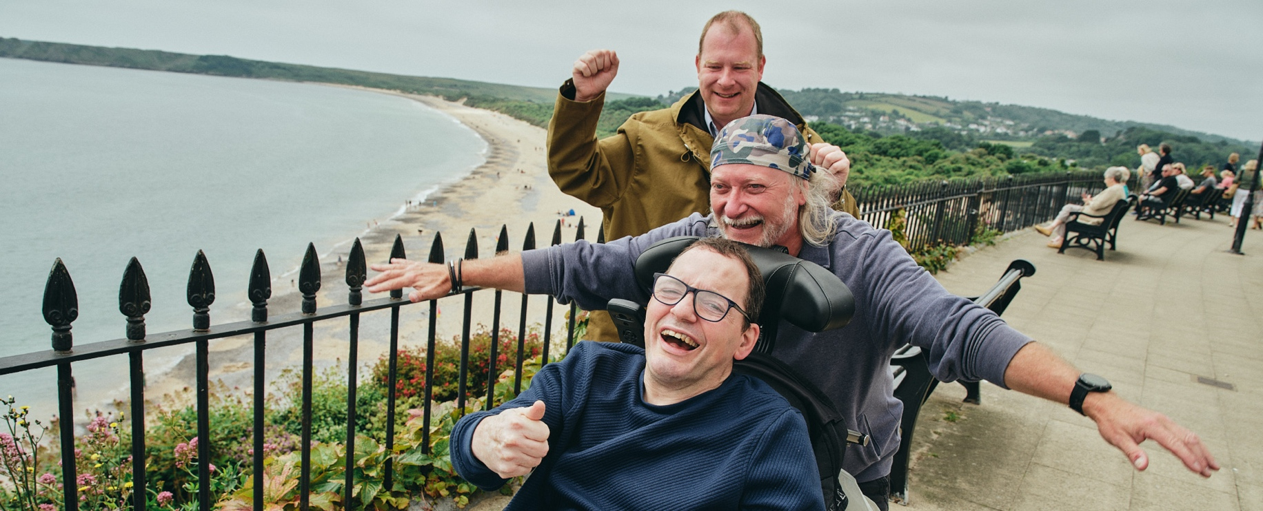

Relief/Support Worker


About the Team and the Role
We have a part time and full time vacancies in our Supported living service in central Aberystwyth. You will work as part of a team who are supportive of colleagues and new starters and who put the people we support at the heart of everything we do.
There are a variety of shift patterns including Sleep ins, days, weekends and bank holidays.
We are committed to work with individuals to ensure a good work life balance.
We will support individuals to activities of their choosing this could be on holidays at home and abroad, concerts, sports events etc. While also supporting them with day to day tasks while encouraging and promoting as much independence as possible.

What is a support worker?
Imagine helping someone achieve something they never thought possible – this is what being a support worker is all about. As a support worker you will support people with a learning disability. Supporting them to live a fulfilled life and one that is as independent as possible. From daily activities to emotional support, you’ll play a role in their everyday happiness and wellbeing. Join us and make a real difference in people’s lives!

What you will bring to the role
- Put the people we support at the heart of everything you do treating them with dignity and respect.
- Supporting the people we support to carry out all the tasks involved in their daily life from cooking to personal care to maintaining important relationships.
- You’ll bring great people skills, a sense of humour, and the confidence to make decisions.
- If you’re enthusiastic about exploring new activities, then you’ll fit right in.
- Previous care experience (but not essential as full training will be given).
- Committed to working as part of and creating a healthy and supportive team environment.

Key requirements
- The ability to work calmly, efficiently and accurately under pressure.
- Be IT confident and keep detailed and accurate records, carrying out all recording and reporting in a person-centred way.
- Hold a valid, clean UK driving licence and have your own car.
- Model our five values in all your work activities (Passionate, Inclusive, Brave, Positive and Kind).
- Be flexible to work sleep ins, weekends and bank holidays.

Please note: This job description is not intended to be exhaustive. Duties and responsibilities may evolve over time to reflect the needs of the organisation and the role.


“This isn’t just a job - it’s a chance to help change the lives of people
with a learning disability and their families. If you’re passionate about
making a difference, join Mencap in building a more inclusive future.”

Shift timings
Most of our services are 24hr care. We prepare the rotas at least 4 weeks in advance so you can still plan your personal and social life!
We will consider flexible working or a particular working pattern that works for you but meets the needs of the people we support.

There is also a non-contractual sleep-in available where you will receive an enhanced flat rate payment of £63.70.

Mencap and our commitment to Safeguarding and Inclusivity
Mencap is committed to safeguarding and promoting the welfare of children, young people and vulnerable adults, and expects all staff and volunteers to share this commitment.
Successful applicants will be subject to appropriate pre-employment checks, including references (one of which, must be your most recent/current employer) and, where applicable, an enhanced Disclosure and Barring Service (DBS) check.

We are an equitable, diverse and inclusive organisation and we particularly welcome and encourage disabled applicants and those from the Black and Asian communities to apply for the role as they are under-represented within the workforce.

Please note: This position does not meet the minimum salary requirements for a Health and Care visa under the UK Skilled Worker route, as set by the Home Office. Therefore, although Mencap is a licensed sponsor, we are unable to offer sponsorship for this role.
Applicants must already have the legal right to work in the UK, as we are not able to support new visa applications or sponsorship requests for this vacancy.

