

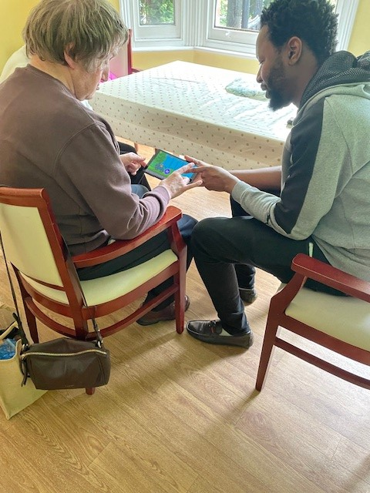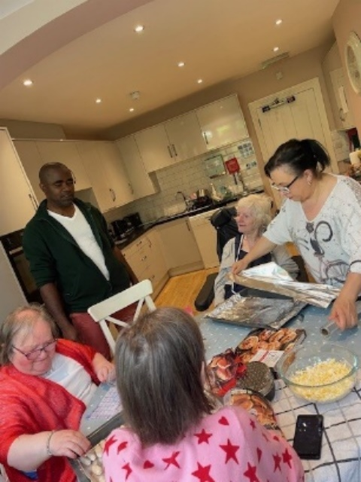

WOULD YOU LIKE TO SUPPORT PEOPLE WITH LEARNING DISABILITIES WHILST WORKING CLOSELY WITH THE PROJECT MANAGER TO LEAD THE TEAM

Please have a read through the following information along with the Job Description and Person Specification included below and think about whether joining our great team is right for you!!

About us

Watford Mencap is a charity providing social care services and support to people with learning disabilities, and their families, in South West Hertfordshire. We are affiliated to Royal Mencap but are a self-funding and independent local charity that has provided services and support to local families for the past 70 years. We enable people with learning disabilities and their families to make the most of life, to enjoy choice and control over their own lives, enabling them to fulfil their life ambitions.

We have worked hard to make our services both efficient and really focused on the person. We have a strong business model that is sustainable and diverse. Our work has expanded, and we are trying new things and ideas across the entire organisation, while keeping everything we do focused on meeting the diverse needs of the people we support. We currently employ 170 staff, have over 20 volunteers and provide support and services to over 500 people with learning disabilities and their families.

This is an exciting opportunity to help, strengthen and develop an established team and you will play an important role, working collaboratively with the people we support, their families and friends, as well as other social and health care professionals. We currently operate across 11 sites in Hertsmere, Three Rivers and Watford.

Working as a Deputy Manager in our Residential Services is varied, rewarding and challenging. It offers you the opportunity to help create a great service that meets the needs of the people you and the team support, as our service develops, and people’s needs change. It also enables you to be an important part of the project management team. This role is for 37.5 hours per week, worked over 5 days across the week.

As an employer, we have achieved Silver Investors in People accreditation and provide employees with access to a full range of professional and personal development opportunities. This includes induction and training programmes, recognised qualifications, regular supervision meetings and an annual appraisal, as well as coaching and mentoring. We value our workers and offer excellent terms and conditions of employment; a range of staff benefits; as well as a competitive salary. You will be joining an award-winning social care organisation that makes a real difference to people’s lives.

OUR VALUES
We are INCLUSIVE. People with learning disabilities are at the heart of everything we do.

We are RESPECTFUL. We work in a person-centred way, whilst listening to the views of all.

We are WELCOMING. We are approachable and value all.

We are PROGRESSIVE. We promote learning to support everyone to achieve their potential.

We are CHALLENGING. Through our work we will push the boundaries for individuals, organisations and society.

Job Description

ABOUT THE ROLE

DEPUTY MANAGER- Residential Services

This is a new post within an established residential team led by an experienced and talented manager, who has been with the organisation for many years. We wish to strengthen the management team in the project in order to respond to the increasing needs of the residents. It is important that candidates have relevant experience of shift leading and are willing to develop their management skills

You will be based in one of our Residential projects – Thorpedale a small home for 7 people but you will be part of a wider team and may, at times, be required to work across the entire service. Appropriate training will be provided and there is an expectation that the successful candidate will have or have achieved a level 4 in Leadership and Management with 18 months of appointment.

Your role will be to assist the Manager in supporting the residents to achieve their goals and to live the lives they wish, while maintaining standards set by the Care Quality Commission (CQC) and Hertfordshire County Council (HCC). The service is at the heart of Chorleywood and part of this role will be to work with individuals to find creative ways to access local resources and enrich their lives.

Qualities of the Deputy Manager by our clients:
Someone who:
- is kind
- listens to us
- likes to cook
- is friendly
- will help us

The job is very varied and as well as leading a shift, supervising staff and completing accompanying paperwork you will act as a Key Worker for individual clients. In this role you will support clients to plan and achieve their goals, review and implement support plans, support clients to attend their own review, liaise with professionals and help individuals manage their money, as well as delivery of direct support. This means a flexible “can do” attitude, good IT skills, alongside an eye for detail, emotional resilience and being able to juggle a broad and diverse workload are all really important in this role.

You will also work closely with the manager to manage the team, induct and supervise staff, shift lead, prepare rotas, complete project audits and play an essential role in ensuring health and safety, medication and record keeping are managed to a high standard.

In return you will find this an extremely rewarding job where you will be making a real difference to peoples’ lives on a daily basis.
“I have really enjoyed developing new knowledge and skills as part of the management team, while still working directly alongside staff and supporting residents. The role allows me to make positive changes, improve residents' everyday lives, and support the team in delivering high-quality care. I also appreciate that every day is different and brings new challenges and opportunities to learn”.
A residential deputy manager
This role involves lone working as well as working alongside colleagues providing personal care and moving and handling. This is a 7-day service which requires working daytime, evenings and weekends as well as sleeping in. As a Deputy Manager you will receive support and leadership from the Service Manager and you will be able to share knowledge and learning with your colleagues in the Residential Project as well as in the wider service and organisation.

Qualities of the Deputy Manager by the team:
- Problem solver
- Good communicator
- Good listener
- Proactive
- Fair
- Respectful
- Part of the team
- Passionate
- Creative

Duties and Responsibilities:
Job Description
DEPUTY MANAGER - Residential Services

Hours: 37.5 hours per week

Reporting to: Thorpedale project manager

Reports: Support workers
Agency workers
Casual workers

Main purpose of the job

- Working with the project manager to lead, support and develop the team to deliver a high-quality person centred service

- To take particular responsibility for the development of enriching the service and the lives of those living there in a creative way.

- To ensure the service works within CQC and contractual frameworks

Supporting Residents

- Ensuring the care and support provided is of a high quality and puts the individual at the centre.

- Ensuring all support is evidenced and records are maintained, involving the individual in all aspects of their lives..

- Work within the necessary legislative frameworks such as the Mental Capacity act to ensure the people we support play a full part in making choices.

- Play an active part in involvement projects, building strong relationships with adults, families and external partners, ensuring regular communication and consultation.

- Establishing positive relationships with individuals, families, professionals and significant others to gain a good understanding of their specific needs and wishes, ensuring they are reflected in the service delivery

- Creating and maintaining person centred support plans on the relevant contact management system, with a positive risk-taking approach focusing on evidencing both outcomes for individuals and a safe and compliant service.

- Building and maintaining strong relationships with stakeholders, including local learning disability teams, commissioners and contract managers

- Identification of risks and ensuring appropriate action is taken to mitigate risk, creating a proactive, honest and achievement driven culture

Leading and Managing the team

- Providing leadership and day to day management to the team implementing new ways of working to ensure that all staff are delivering flexible high-quality personalised services and support. Ensuring team meetings, supervision, appraisal and induction takes place in a timely manner.

- Work flexibly as part of the service leadership team covering shifts where necessary and providing on call services to support the wider organisation.

- Working with the service manager help to produce and mange rota’s, ensuring that safe staffing levels are always in place

- Working with the Service Manager to carry out recruitment, induction, probation, supervision, appraisals and training for all staff ensuring procedures meet safer staffing guidelines.

- Being a role model for the team as well as the wider support at home team, building strong bonds across the teams.

- To promote effective teamwork and communication, modelling proactive and positive leadership.

- Be able to meet the needs of people through a flexible rota. This will involve working days, evenings & weekends as well as sleeping in and providing cover as required in the event of staff shortages.

Financial Stability and Project Resources

- To monitor and evidence the use of hours and support provided, submitting required information in line with funding agreements, alongside the Project Manager.

- Support the manager to provide an efficient service, managing and reviewing financial performance and ensuring items recharged where appropriate.

- In conjunction with the manager ensure the service is well maintained, managing repairs, ensuring resources in place, managing cleaning, maintenance etc.

- Work creatively to build networks with the local community to enable increased opportunities for the clients alongside a good working relationship with the volunteer co-ordinator to build additional resources.

Safety and Quality

- Manage risk within the service, taking a positive risk approach where possible.

- To ensure the service meets contractual requirements and continues to comply with any relevant current regulation and legislation as well as compilation of contractual records and monitoring data, completing monthly project audits

- To follow best practice guidance regarding Safeguarding, CQC , Health and Safety and managing risks legislation to promote independence

- To report any significant issues, notifiable events, or concerns through line management channels, including when working out of hours if needed

- To be an emergency point of contact as required, participating in on call system

General

- To preserve and respect the dignity and privacy of people and their families and observe confidentiality at all times.

- To support anti-discrimination policies and procedures and promote equality of opportunity at all times

- To be familiar with and work within the organisation and the service values policies and procedures, maintaining records and reports accordingly.

- To make full use of the organisations IT systems ensuring confidentiality is maintained at all times.

- To attend and participate in team meetings, supervisions, appraisals and training as requested and required by your manager including working across the Support at Home team

- To undertake such additional duties appropriate to the post and to support the organisation’s wider goals by working flexibly across the organisation from time to time as determined by your manager.

This job description may be reviewed annually to meet changing service requirements.

Person Specification:
Deputy Manager - Residential

Requirement | Essential | Desirable
Education | - Evidence of commitment to continuing self-development  - Willingness to work towards and gain a Level 4 management qualification within 18 months, if you don’t already have one | - First Aid qualification  - Level 3 social care qualification or equivalent
Experience | - Experience of working in and shift leading within a residential or supported living setting  - Inducting new staff, preparing rota’s and allocating tasks.  - Delivering a range of support and activities for adults with disabilities.  - Experience of working with adults with dementia as well as dual diagnosis of Learning Disability and Mental Health needs.  - Engaging with and supporting families  - Supporting colleagues, using systems, ensuring compliance and quality  - Proven ability to successfully support people, working with and building relationships with people at all levels  - Delivering high quality customer service  - Managing medication | - Experience of delivering supervision  - Enabling people to access new opportunities  - Supporting people with profound and multiple learning disabilities and high health needs  - Building and maintaining effective multi agency working relationships
Skills | - Able to work using own initiative, plan and prioritise workload, and contribute own ideas to support service delivery  - Communicate effectively and sensitively with different people, including good standard of written English. To be able to report and record accurately.  - Support adults in a creative way that respects choice, dignity, respect and privacy  - Form and maintain effective working relationships with individuals being supported, their families, colleagues  - Maintain accurate written and financial records and follow policies and procedures  - Good IT skills: competent in the use of Microsoft Office; emails; able to access e-learning; use electronic systems to upload records and reports | - Able and interested in using IT to support alternative communication methods  - Previous use of a contact management system.
Knowledge | - Knowledge of the needs and rights of adults with a learning disability and an understanding of the issues which people may face.  - Knowledge of legislation affecting adults  - Knowledge of Care Quality framework  - Knowledge of Health and safety and Risk management policy and procedure | - Knowledge of different communication methods  - Knowledge of local community
Personal attributes | - A positive, calm and pragmatic approach. resilient, firm and fair  - Happy to do practical day to day tasks and to offer a high standard of customer service  - Ability to balance a varied and demanding workload, whilst dealing confidently with people at all levels  - Able to motivate and generate enthusiasm  - Able to work on own initiative, introducing new solutions and innovative ways of improving people’s lives and the way we work  - Able to work flexibly to meet the demands of the job, including evenings and weekends  - Excellent organisational skills  - Able to respect confidentiality and to work in a professional and sensitive manner
General | - Able to prioritise and work flexibly to meet the needs of individuals, the service and organisation.  - Confident to work alone when required.  - Able to provide out of hours management cover as part of the on-call rota.  - Able to demonstrate genuine commitment to the values and goals of Watford Mencap. | - Able to drive with current clean driving licence.

Our Values
To be successful in this role we expect you to share and live our values:

Value | Behaviour
Inclusive | You involve the people you support to live the life they choose by listening to them, planning with them and advocating for them.
Inclusive | You are able to communicate effectively with people with a learning disability, adapting your approach to the needs of the person at the time.
Inclusive | You have an awareness of and commitment to equal opportunities for all.
Respectful | You support people in a way that respects choice, dignity, diversity and privacy.
Respectful | You develop and maintain effective working relationships with people you support, their families, colleagues and partner organisations.
Respectful | You work flexibly and can adapt to changes in workload as necessary.
Respectful | You can support the manager to bring the team and people you support with you.
Welcoming | You can communicate positively with a range of people with differing abilities.
Welcoming | You can develop and maintain a welcoming atmosphere for the people you support and their families, and your colleagues.
Welcoming | You can work with other health and social care professionals to meet the needs of the people you support.
Progressive | You are keen to learn new things and develop your social care knowledge.
Progressive | You are able to record information, access and manipulate data stored in IT systems and share information easily and appropriately.
Progressive | You are innovative with ideas and passionate about developing the service.
Progressive | You are able to think creatively to develop more effective systems as the needs of the project changes.
Challenging | You professionally challenge prejudices that cause barriers for people living with learning disabilities.
Challenging | You will use all available information to ensure that the support packages commissioned meet the needs of the people you support whilst maintaining effective working partnerships.

