About the job

 | The job is called Healthier Me Champion
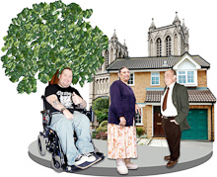 | The job is helping to make Oldham, Rochdale & Tameside a healthier place for people with a learning disability to live in.
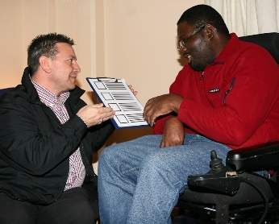 | The job involves speaking to people in the local area and in Mencap services about health and wellbeing.
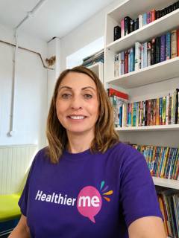 | The Healthier Me Champions will be managed and supported by Nicola Garbutt
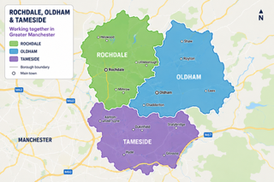 | The job is based across Oldham, Rochdale & Tameside
 | This is a part time job for 16 hours per month.  We will pay £12.71 per hour.
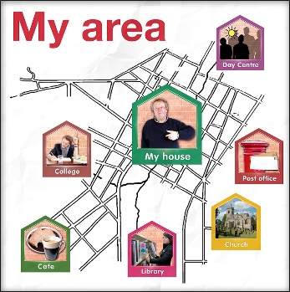 | You must live in Oldham, Rochdale or Tameside  You will travel to meetings around the area and sometimes work at home.

What will the Healthier Me Champion do?

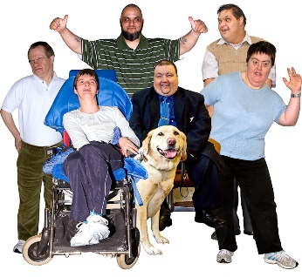 | Work with lots of different people in the local community and at Mencap.  You will build good relationships with people.
 | Inspire people with learning disability to be healthy and active.
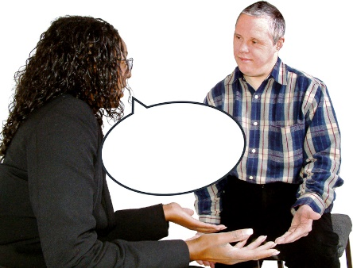 | Listen to Mencap teams, local organisations and people with a learning disability to find out:  - What is important to them.  - The difficulties they face around health.
 | Help the Healthier Me Coach to run meetings and events and help to collect feedback.
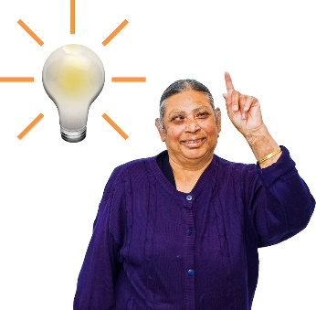 | Have a positive attitude.
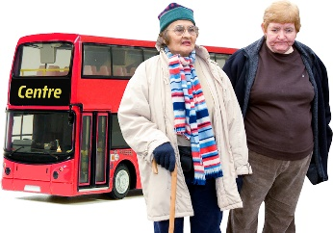 | Travel to different places in the area for work.
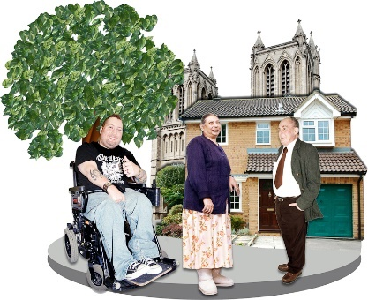 | Tell people about why it is important to include people with a learning disability in the community.
 | You will need to be able to travel to different places.  This could be using public transport, driving or getting a lift from family and friends.

Other important information

 | Working hours might be on different days and times.
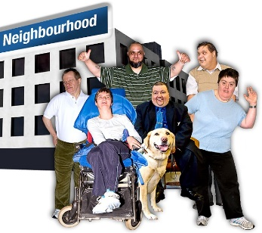 | You should have a good understanding of the local area.
 | You should be willing to learn how to use a smartphone, laptop or tablet.
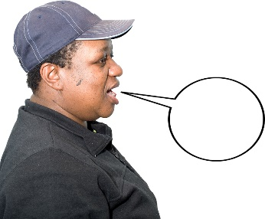 | You should be confident to talk to new people and build relationships with individuals and organisations.  You will always be friendly and helpful.
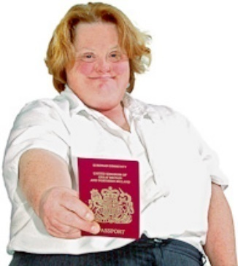 | If you are asked to come for an interview, you will need to bring your ID documents with you. This will include:  - A passport or your birth certificate  - National Insurance number

Are you interested in being a Healthier Me Champion?

Ways you can apply
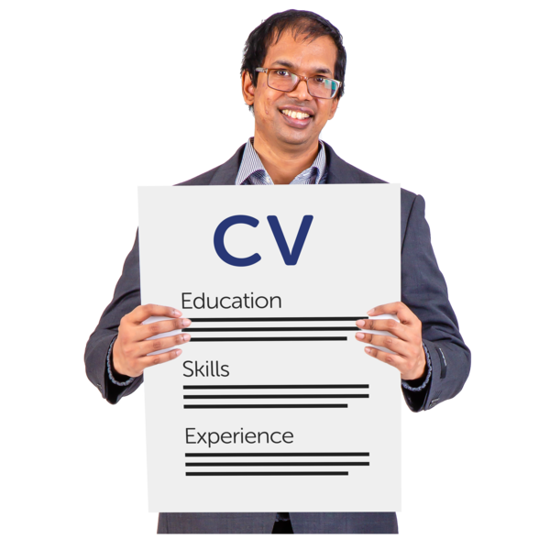 | You can apply on our website using the 'Apply' button
 | If you would like to apply by sending a video explaining why you want to do this job, please contact Alesha Hill by email: alesha.hill@mencap.org.uk
 | If you have any questions, or would like support with applying, please get in touch with Nicola Garbutt and Nicola.garbutt@mencap.org.uk or calling: 07483 409840
 | This advert will close on 19th August 2026  Interviews will be on the

Mencap’s Values and how they apply to this role
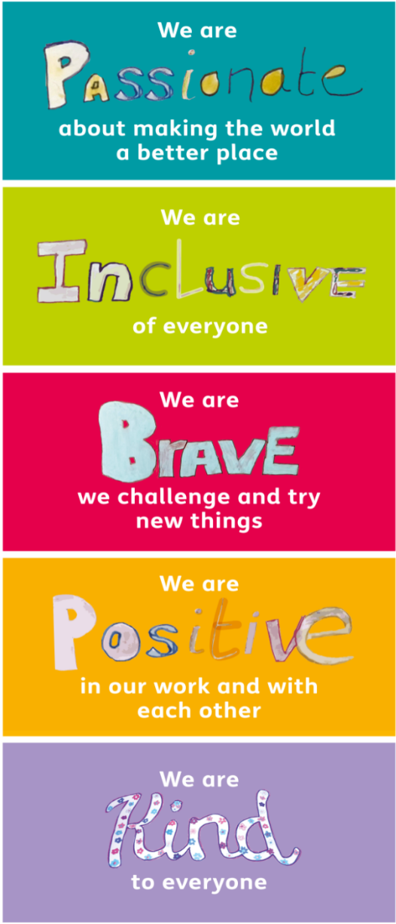
You will be passionate about helping the community.
You will be inclusive by working with different people and listening to everyone.
You will be brave to meet new people and support their ideas.
You will be positive in how you work with other people.
You will be kind to everyone you work with.

