Healthier Me Champion
Northallerton, North Yorkshire
This is a role for a person with a learning disability.
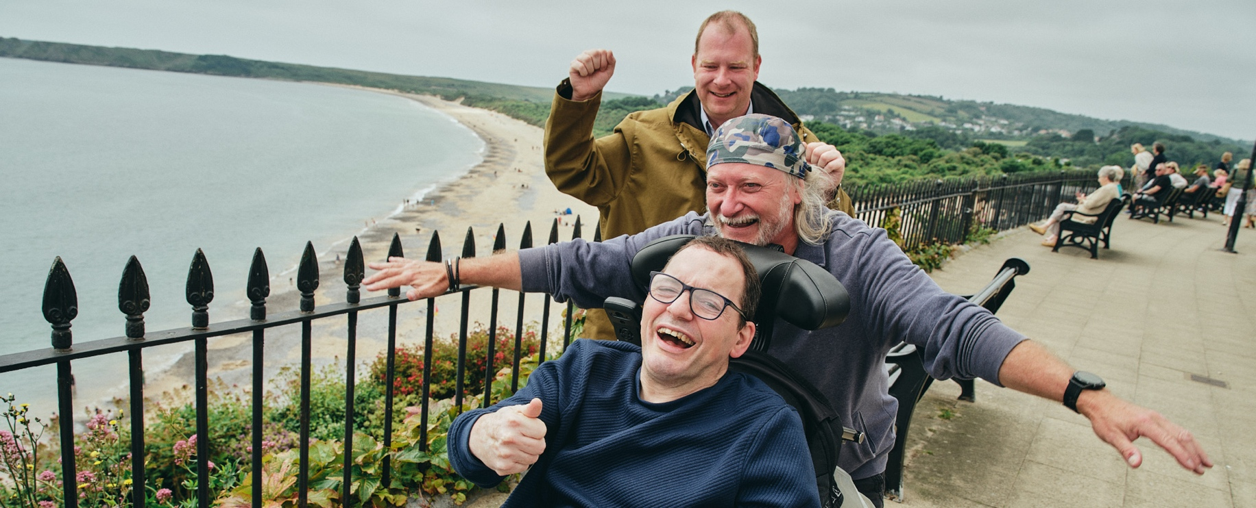
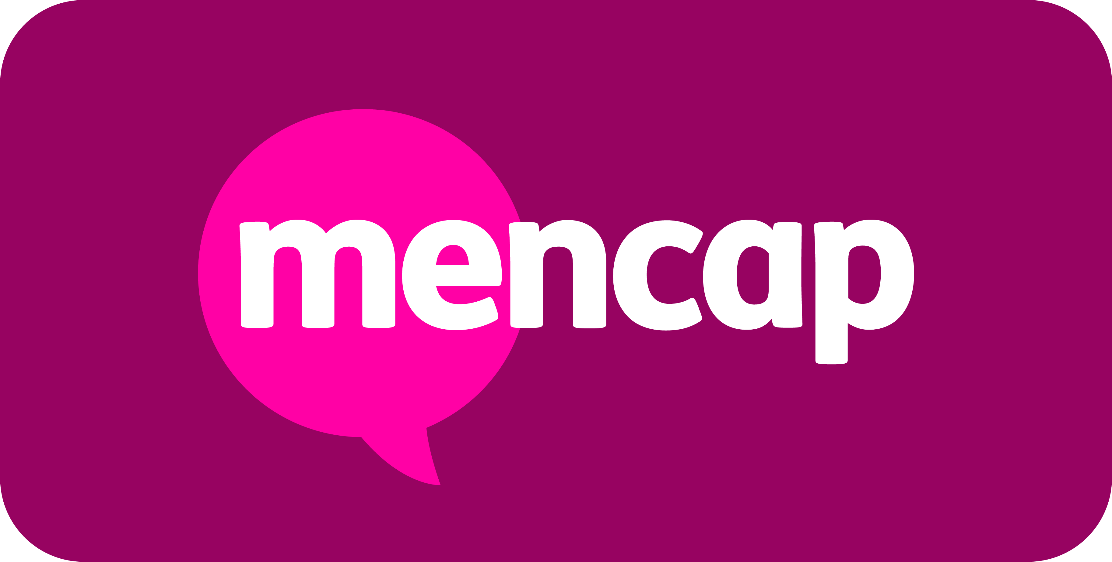

About the Team and the Role
This role is for 4 hours a week/ 16 hours per month.
It will mainly be located at Northallerton and the Dales Mencap Society, Northallerton, DL6 1EG. But occasionally you may be asked to independently travel locally or work from home.
The role pays £12.71 per hour. This role is until October 2027.
The Healthier Me Champion will be part of our exciting new Healthier Me programme at Mencap.
The Healthier Me programme wants to improve health and wellbeing for and with people with a learning disability.
As a Healthier Me Champion you will work in your local area with your manager, the Healthier Me Coach. You might be asked to do some work from home.
Healthier Me Champions will:
- Encourage people with a learning disability to make healthy choices.
- Help local groups and services to be more accessible to people with a learning disability.
- Help the Healthier Me Coach (your manager) to run workshops and meetings (with support).
- Meet people in Mencap services and tell them about Healthier Me.
- Join online meetings with other Healthier Me Champions around the UK to share your ideas and experiences and listen to others.

What you will bring to the role
We are looking for someone who:
- Is passionate about health and wellbeing.
- Is Positive, Kind, Inclusive, Brave and Passionate – these are Mencap’s values and they are very important to us.
- Can travel independently to Northallerton for weekly work.
- Can occasionally travel independently or get a lift to another local setting for work.
- Can occasionally work from home, if needed.
- Is willing to try and learn new things.
- Can use a computer/tablet (this will be provided).
- Has knowledge of the local area.
If you have some or all of these skills – we want to hear from you!
Please click on the ‘APPLY’ button at the top of this page. You can upload your CV and fill in your details.
OR you can send us a short video application (maximum 3 minutes). Include in your video why you would be a good fit for this role and any relevant experience or skills you have.
Please send your video application to alesha.hill@mencap.org.uk with the subject as ‘Healthier Me Champion Northallerton’.
This advert will close on 7th August 2026.
Interviews will be held on Monday 24th August 2026 (time to be confirmed) at Northallerton and the Dales Mencap Society, Goosecroft Lane, Northallerton, DL6 1EG.
If you need help applying for this job, please get in touch with Kate McGowan at kate.mcgowan@mencap.org.uk or calling: 07483700015. My working days are Tuesday-Thursday. Please note that I am on annual leave 4th-6th August.

Please note: This job description is not intended to be exhaustive. Duties and responsibilities may evolve over time to reflect the needs of the organisation and the role.


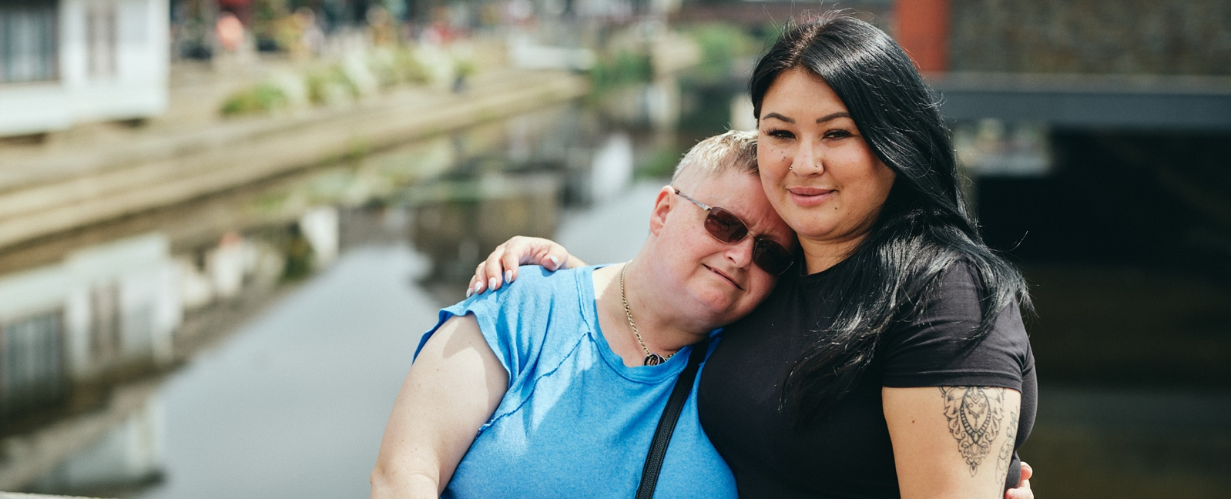

“This isn’t just a job - it’s a chance to help change the lives of people
with a learning disability and their families. If you’re passionate about
making a difference, join Mencap in building a more inclusive future.”

Mencap and our Commitment to Safeguarding
Mencap is committed to safeguarding and promoting the welfare of children, young people and vulnerable adults, and expects all staff and volunteers to share this commitment.
Successful applicants will be subject to appropriate pre-employment checks, including references and, where applicable, an enhanced Disclosure and Barring Service (DBS) check.

